Reopening an airport in Ukraine and Foreign Direct Investment:

Suggestive Empirical Analysis

Authors: Charles Becker, Peter Devine, and Michelle Schultze[1]

Date: March 25, 2024

## Executive Summary

This paper explores the potential effects on the Ukrainian economy of re-opening one of its major airports (Boryspil, adjacent to Kyiv, or Lviv). We conduct two types of empirical work to assess the economic impact of airport travel expansion, one using US carrier flight data, and one using total passenger arrivals. We also discuss the economic structure of those regions of Ukraine most likely to be affected by airport reopening.

We find substantial evidence that the relationship between an increase in passengers flying into the country (on US carriers) and total FDI is positive and increasingly so as the increase in passengers becomes larger, even when controlling for battle fatalities, GDP, and other metrics. **This supports the hypothesis that opening an airport in Ukraine, even during wartime, would likely result in an increase in FDI and hence economic growth.**

## Analysis

We seek to obtain a broad sense of the potential economic value of reopening one of Ukraine’s two most important airports. To get at this, we first discuss the structure of Ukraine’s economy with reference to airport location. We then establish broad parameters related to the potential economic value of airports . Finally, we discuss the relative merits of reopening Lviv and Boryspil airports.

Ukraine’s exports of both goods and services are dominated by Kyiv, as are its imports. The immediately surrounding area adds to its dominance. Dnipropetrovska region to the east ranks second in terms of goods’ exports and third in terms of imports; Lviv is fourth in terms of goods exports and second in terms of imports. Vinnytsia, Chernivtsy, and Odesa to the south are all important, and are roughly equidistant from Lviv and Boryspil. Reopening airports in the eastern and southeastern industrial heartlands are impractical for security reasons.

Indeed, despite the economic dominance of Kyiv, the costs of reopening Boryspil Airport likely are prohibitive at this time. While the airport itself can be defended against missile attacks and while deliberate attacks on civilian airliners are unlikely, the risk of mistaken identity is substantial, and the cost of insurance (and prospective passengers’ reluctance to fly) likely makes Boryspil infeasible. The relative attractiveness of Lviv is further enhanced by the ubiquity of rapid passenger train service from Lviv (all figures taken from <https://e-bilet.ua/en>)

Passenger train time from Lviv to other cities

**Destination**: **Trip duration**: (rounded to the nearest half hour)

Kyiv 6:30 – 7:00

Dnipro 6:00 (additional from Kyiv)

Ivano-Frankivsk 2:00

Kharkiv 13:30

Odesa 10:30

Poltava 14:30

Ternopil 1:30

Vinnytsia 4:30

It is true that not all major routes appear to be served at this time. However, it also seems reasonable to anticipate that Ukrainian Railways would modify its schedules (and quality of service) with the reopening of Lviv Airport, and that a substantial portion of Ukraine would be within more-or-less reasonable access.

To get a quick-and-dirty sense of economic impact, we explore two approaches. The first involves simple linear regression of levels on levels, using quantile regression to focus on the magnitude of effects, followed by first differences (percentage changes) regressions. We obtain monthly flight data from the United States to all international destinations, by US carriers for roughly the past three decades, from the [Bureau of Transportation Statistics](https://www.bts.gov/browse-statistical-products-and-data/bts-publications/data-bank-28im-t-100-and-t-100f-internationa-0). We also obtain annual macroeconomic data, including foreign direct investment estimates, for the same time period, from [World Bank Development Indicators](https://databank.worldbank.org/source/world-development-indicators). We fill in some data from Ukraine in 2023 from International Monetary Fund estimates (IMF Country Report No. 23/399). Finally, to hone in on the impact of flight resumptions on FDI in conflict areas, we obtain annual [ACLED conflict data](https://acleddata.com/data-export-tool/) for each country.

Total FDI for year *t* is then regressed on the **total** number of passengers flying into a country year *t-1* (transformed by ln (1 + number) due to the magnitude of passengers) and split into 10 deciles to investigate the effects at different passenger levels. This is the simplest regression we ran, and it was significant at all deciles except for the first (Table 1 and Figure 1, drawn from this [table](https://docs.google.com/spreadsheets/d/1zdZJibggs3bnYIdH_IBEw_Yauh2jkaMT/edit?usp=sharing&ouid=108231700962108858345&rtpof=true&sd=true) and [plot 5](https://drive.google.com/drive/folders/1aWE8uHWehkzHYkhUEF-UIRIQb_Y1fTOj?usp=drive_link)), showing that with the base relationship, the relationship between passengers flying into a country on US carriers and FDI in that country grows stronger as there are more passengers flying in.

Total FDI (Y) was next regressed on the **percent change** in passengers flying into the country (X, transformed by ln (X+1) due to the magnitude of many changes), again binned by decile to investigate the effects at different X levels. Taking logarithms produces undefined values from negative values; we therefore restrict the data set, effectively narrowing the interval of study of the passenger numbers’ variable to just positive changes. As we are examining deciles, this restriction effectively means that we are omitting what would be the lowest deciles of the unrestricted X variable, simply “zooming in” our analysis to the higher deciles. Significant and positive changes were observed for the middle 20-90% of the X variable (Table 2, Figure 2), therefore **the relationship between an increase in passengers flying into the country and total FDI *becomes more positive* as the increase was larger.**

This relationship between lagged passengers and FDI holds even when controlling for natural log of battle fatalities (drawn from ACLED data from that same year and country) (Table 3, Figure 3), though is again only significant for the middle 20-90% of the X1 (log of increase in passengers) variable.

Lastly, the relationship holds even when controlling for GDP in terms of current (2022) USD, though it is only significant for the latter 40-100% deciles of the X1 (log of increase in passengers) variable (Table 4, Figure 4). Please note the spike in the beta at the end, which is significant for the passengers’ variable.

The **second approach** involves a difference-in-differences specification and also draws on global flight data. As before, we obtain battle fatalities numbers from the ACLED dataset; we also take annual airport air traffic, FDI, and GDP data from the World Bank, regressing on a subset of countries for which we had full data (N=846). While traffic observations are at the airport level, other data are all at the country level.

ln(FDI/GDP + 1) = α0 + α1(ln_battle_fatalities) + α2(ln_GDP) + α3(treatment) + α4*(post_treatment) + α5(ln_battle_fatalities * treatment) + ε

That is, we regress FDI on battle fatalities, GDP, the interaction between ln battle fatalities (plus 1) and the treatment variable (coded as “1” for any year after the largest percentage increase in a country's air traffic, given that the amount at least doubles), the treatment variable itself, and the post*treatment variable (the number of years after the first treatment year).

This regression yields significant results for the interaction term, showing that **while controlling for battle fatalities and GDP, a country’s FDI is positively associated with a spike of air traffic when interacting with battle fatalities**. This interaction term has a positive coefficient; as anticipated, battle fatalities themselves have a negative effect on FDI. A spike in air traffic does not have a significant relationship with FDI on its own in this model. However, if one removes the post-treatment variable, there is a positive relationship between just the treatment and log+1 of total FDI, significant at the 5% level.

**Bottom line**: contemporaneous and lagged air traffic is associated with increased foreign direct investment, especially for countries/airports with modest traffic. The obvious criticism of this approach is that the terms are likely cointegrated (tests to follow subsequently), limiting claims to having uncovered causal inference. However, the positive significance of an air traffic surge in areas with high battle fatalities on FDI seems more likely to be unidirectional: it seems unlikely that FDI has a non-idiosyncratic causal impact on battle fatalities.

## Economic structure figures and table

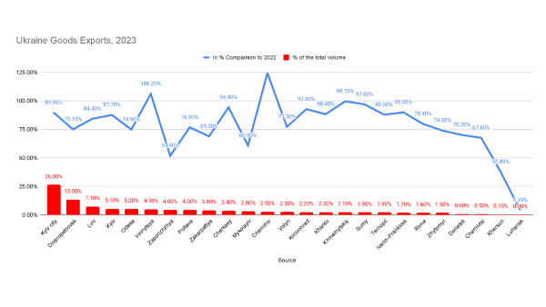

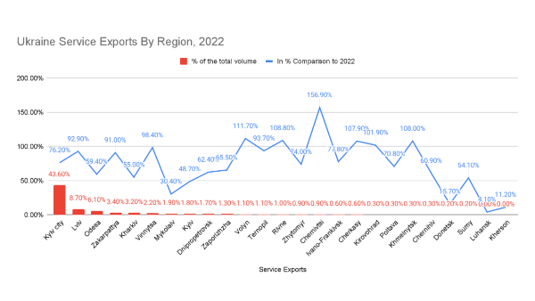



Source(s) <https://www.ukrstat.gov.ua/>

## Airports and economic growth: quantile regressions

Table 1:

Coefficient values and intercept values produced by regressing total FDIt on ln(1 + total passengers flying into a country)t-1, split by deciles of the X variable*.*

|  |  |  |
| --- | --- | --- |
| Tau | variable | coefficients |
| 0.1 | Intercept | 31020000*** |
| 0.1 | ln_pass | -2184000 |
| 0.2 | Intercept | 93940000*** |
| 0.2 | ln_pass | 29790000*** |
| 0.3 | Intercept | 241600000*** |
| 0.3 | ln_pass | 71060000*** |
| 0.4 | Intercept | 357500000*** |
| 0.4 | ln_pass | 179800000*** |
| 0.5 | Intercept | 477600000*** |
| 0.5 | ln_pass | 339500000*** |
| 0.6 | Intercept | 716900000*** |
| 0.6 | ln_pass | 615800000*** |
| 0.7 | Intercept | 1.111e+09*** |
| 0.7 | ln_pass | 1.185e+09*** |
| 0.8 | Intercept | 1.691e+09*** |
| 0.8 | ln_pass | 2.194e+09*** |
| 0.9 | Intercept | 3.324e+09*** |
| 0.9 | ln_pass | 4.452e+09*** |
| 1 | Intercept | 1.457e+11*** |
| 1 | ln_pass | 1.64E+10 |

*Figure 1: Plot of the beta values produced by regressing total FDI on natural log+1 of *total* passengers flying into a country from the previous year, split by deciles of the X variable.*

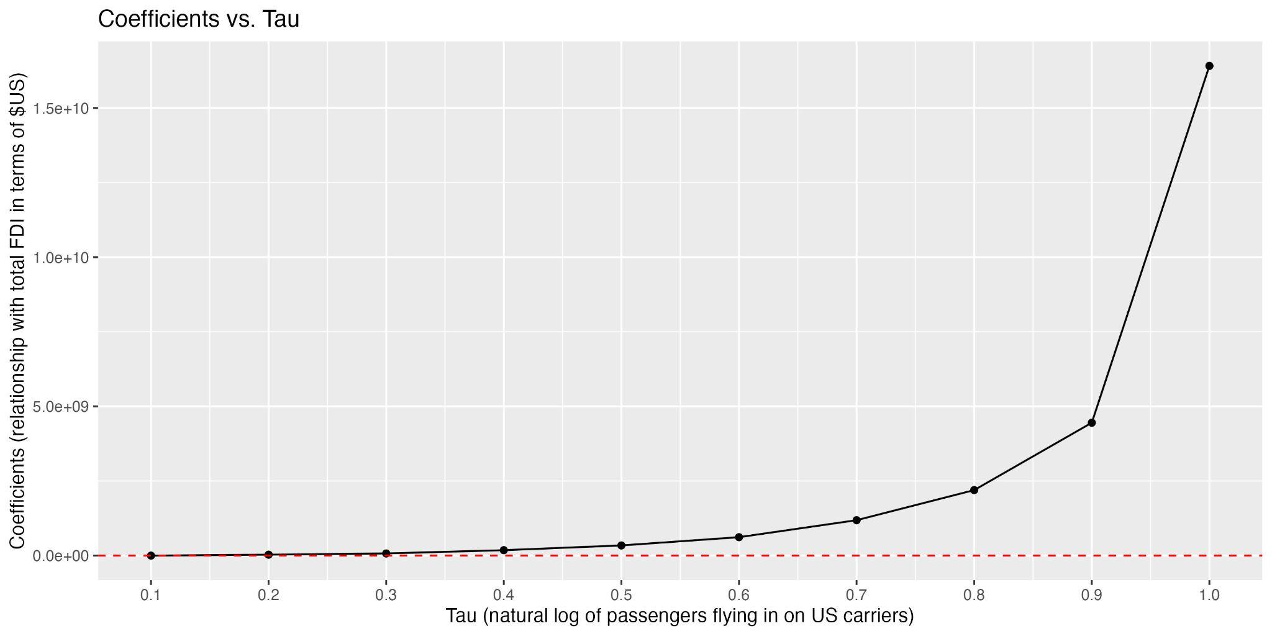

Table 2:

Coefficient and intercept values produced by regressing total FDI on ln (X+1) of percent change in passengers flying into a country from the previous year, split by deciles of the X variable*.*

|  |  |  |
| --- | --- | --- |
| tau | variable | coefficients |
| 0.1 | Intercept | 36910000*** |
| 0.1 | ln_passengers_pct | -7617000 |
| 0.2 | Intercept | 142500000*** |
| 0.2 | ln_passengers_pct | 83980000 |
| 0.3 | Intercept | 307200000*** |
| 0.3 | ln_passengers_pct | 299900000*** |
| 0.4 | Intercept | 458500000*** |
| 0.4 | ln_passengers_pct | 507600000*** |
| 0.5 | Intercept | 815500000*** |
| 0.5 | ln_passengers_pct | 951800000*** |
| 0.6 | Intercept | 1.229e+09*** |
| 0.6 | ln_passengers_pct | 1.576e+09*** |
| 0.7 | Intercept | 1.843e+09*** |
| 0.7 | ln_passengers_pct | 3.503e+09*** |
| 0.8 | Intercept | 3.595e+09*** |
| 0.8 | ln_passengers_pct | 6.586e+09*** |
| 0.9 | Intercept | 1.758e+10*** |
| 0.9 | ln_passengers_pct | 1.435e+10*** |
| 1 | Intercept | 2.611e+11*** |
| 1 | ln_passengers_pct | 4.90E+10 |

Figure 2:

Plot of coefficient values produced by regressing total FDI on ln (X+1) of percent change in passengers flying into a country from the previous year, split by deciles of the X variable.

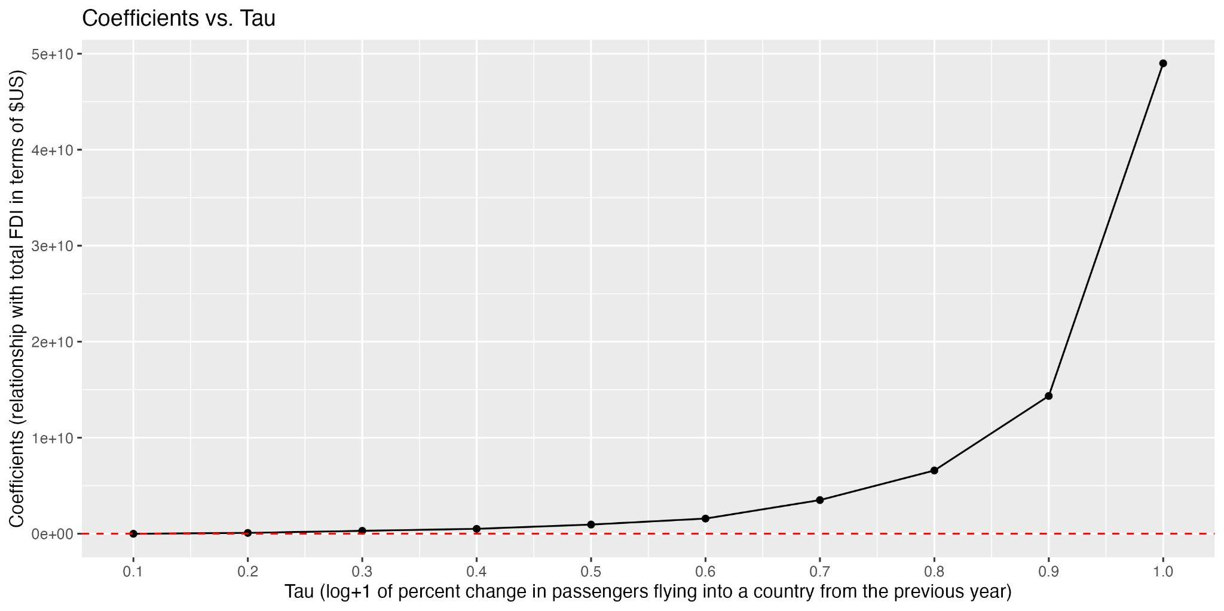

Table 3:

Beta values (under ln_passengers_pct) and intercept values produced by regressing total FDI on ln (X+1) of percent change in passengers flying into a country from the previous year, split by deciles of the X1 variable, controlled by the natural log+1 of battle fatalities.

Beta values of ln_battle_fatalities can be found at the associated spreadsheet [here](http://here). These coefficients are only significant for the middle 40-90% of X1 (log in percent change in passengers).

|  |  |  |
| --- | --- | --- |
| tau | variable | coefficients |
| 0.1 | Intercept | 40870000*** |
| 0.1 | ln_passengers_pct | -7935000 |
| 0.2 | Intercept | 143200000*** |
| 0.2 | ln_passengers_pct | 83720000 |
| 0.3 | Intercept | 305200000*** |
| 0.3 | ln_passengers_pct | 299700000*** |
| 0.4 | Intercept | 472800000*** |
| 0.4 | ln_passengers_pct | 501500000*** |
| 0.5 | Intercept | 9.18e+08*** |
| 0.5 | ln_passengers_pct | 920500000*** |
| 0.6 | Intercept | 1.357e+09*** |
| 0.6 | ln_passengers_pct | 1.572e+09*** |
| 0.7 | Intercept | 2.059e+09*** |
| 0.7 | ln_passengers_pct | 3.51e+09*** |
| 0.8 | Intercept | 4.541e+09*** |
| 0.8 | ln_passengers_pct | 6.488e+09*** |
| 0.9 | Intercept | 2.114e+10*** |
| 0.9 | ln_passengers_pct | 1.512e+10*** |
| 1 | Intercept | 3.28E+11 |
| 1 | ln_passengers_pct | 3.14E+09 |

Figure 3:

Plot of coefficient estimates produced by regressing total FDI on ln (X+1) of percent change in passengers flying into a country from the previous year, split by deciles of the X variable, and controlled by the natural log+1 of battle fatalities.

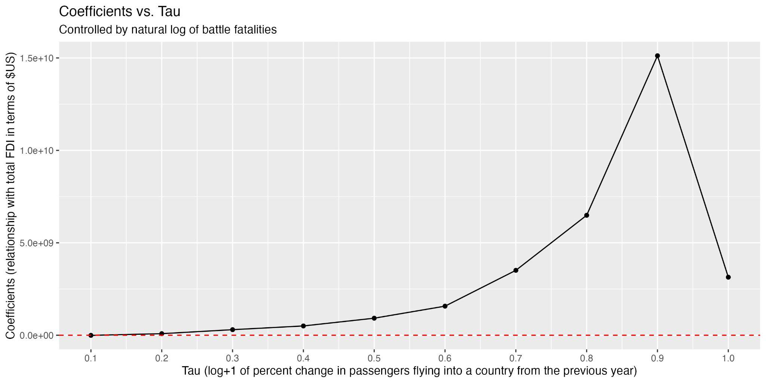

Table 4:

Beta values (under ln_passengers_pct) and intercept values produced by regressing total FDI on ln (X+1) of percent change in passengers flying into a country from the previous year, split by deciles of the X1 variable, controlled by ln of battle fatalities +1 and total GDP in terms of current USD. Beta values of ln_battle_fatalities and the GDP variable can be found at the associated spreadsheet [here](http://here).

|  |  |  |
| --- | --- | --- |
| tau | variable | coefficients |
| 0.1 | Intercept | -113800000 |
| 0.1 | ln_passengers_pct | -231200000 |
| 0.2 | Intercept | -18840000 |
| 0.2 | ln_passengers_pct | -19250000 |
| 0.3 | Intercept | 36880000* |
| 0.3 | ln_passengers_pct | 18480000 |
| 0.4 | Intercept | 96630000* |
| 0.4 | ln_passengers_pct | 70090000 |
| 0.5 | Intercept | 167100000*** |
| 0.5 | ln_passengers_pct | 205700000*** |
| 0.6 | Intercept | 223100000** |
| 0.6 | ln_passengers_pct | 257200000*** |
| 0.7 | Intercept | 504500000*** |
| 0.7 | ln_passengers_pct | 269700000*** |
| 0.8 | Intercept | 9.67e+08*** |
| 0.8 | ln_passengers_pct | 366800000* |
| 0.9 | Intercept | 2.144e+09*** |
| 0.9 | ln_passengers_pct | 1.116e+09* |
| 1 | Intercept | 6.85e+10*** |
| 1 | ln_passengers_pct | 3.417e+10. |

Figure 4:

Plot of the beta values produced by regressing total FDI on ln of percent change in passengers flying into a country from the previous year, for nonnegative observations, split by deciles of the X variable, and controlled by the ln battle fatalities (+1) and total GDP in terms of USD.

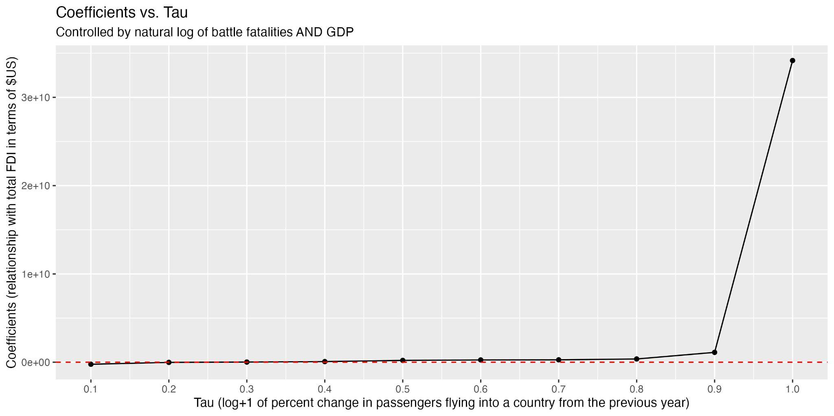

## Additional Robustness Checks

Several additional robustness checks were implemented on the first regression mentioned, the log+1 of *total* passengers variable. These included weighing the results based on log+1 of battle fatalities (and other fatalities variables). We also implemented a lead on the FDI variable (to regress NEXT year’s FDI numbers on THIS year’s log+1 of total passengers flying into the country), and controlling by a lag on battle fatalities (testing the relationship between THIS year’s FDI variable and THIS year’s total passengers flying into the country, when controlled by LAST year’s battle fatalities). Each of these regressions had significant coefficients between 20-90% of the X variable and followed the same positive shape (see this [table](https://docs.google.com/spreadsheets/d/1zdZJibggs3bnYIdH_IBEw_Yauh2jkaMT/edit?usp=sharing&ouid=108231700962108858345&rtpof=true&sd=true) and [plots 6-13](https://drive.google.com/drive/folders/1aWE8uHWehkzHYkhUEF-UIRIQb_Y1fTOj?usp=drive_link)). Controls were also included in the model to avoid endogeneity issues regarding battle fatalities and GDP, reaffirming the effects (see this [table](https://docs.google.com/spreadsheets/d/1nhn1rV_4HwozF8jfCxmkC7sDrtyFVeTm/edit?usp=sharing&ouid=108231700962108858345&rtpof=true&sd=true)).

The regressions using log+1 *percent change* in passengers were also replicated by implementing a lead on the FDI variable and a lag on battle fatalities (with the logic specified in the above paragraph). Both were significant and mirrored the other regressions (see this [table](https://docs.google.com/spreadsheets/d/1bRHO4N1yGBsNtLCLFuWsywLJBNL68pCC/edit?usp=sharing&ouid=108231700962108858345&rtpof=true&sd=true) and [plots 23-24](https://drive.google.com/drive/folders/1aWE8uHWehkzHYkhUEF-UIRIQb_Y1fTOj?usp=drive_link)). When implementing a robustness check by filtering the data for only years where the country experienced over 100 battle fatalities, the results were not very significant, but mirrored the other regressions in terms of shape ([plot 25](https://drive.google.com/drive/folders/1aWE8uHWehkzHYkhUEF-UIRIQb_Y1fTOj?usp=drive_link))

Note that we also tried using percent change in passengers flying into the country (without the log), as well as percent change in total FDI (rather than total amount of FDI), and found not very significant results (see this [table](https://docs.google.com/spreadsheets/d/1bRHO4N1yGBsNtLCLFuWsywLJBNL68pCC/edit?usp=sharing&ouid=108231700962108858345&rtpof=true&sd=true) and [plots 14-19; 26-31](https://drive.google.com/drive/folders/1aWE8uHWehkzHYkhUEF-UIRIQb_Y1fTOj?usp=drive_link)). Running the regressions with log+1 of the percent changes in **both** FDI and passengers flying into the country did not solve the problem, since taking the log+1 of the percent change in FDI produced many NAs, since several countries had negative net inflows of FDI into the nation, biasing the beta values.

*Please contact Michelle Schultze for any queries regarding this write-up (*[*mks84@duke.edu*](mailto:mks84@duke.edu)*).*

Figure 5:

Diff-in-diff regressions of the effect of air traffic on foreign direct investment, using global airline traffic data

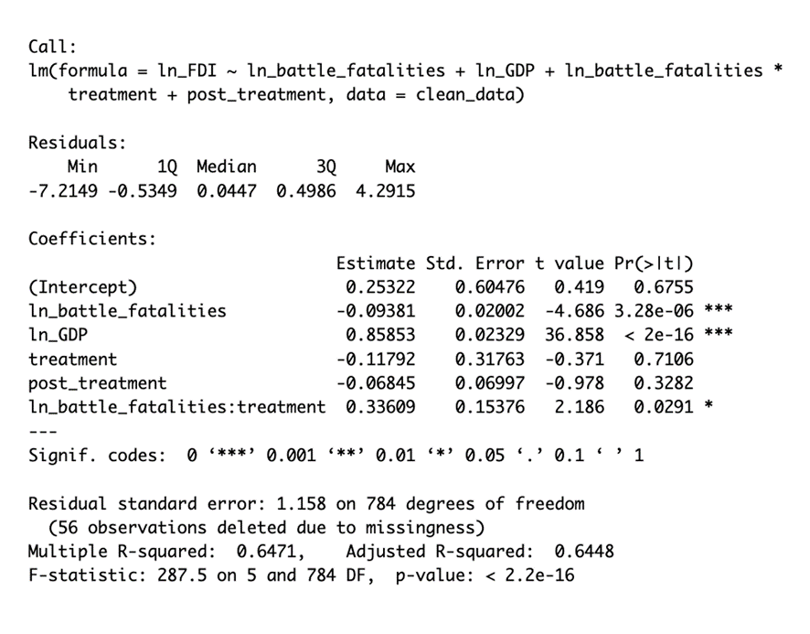

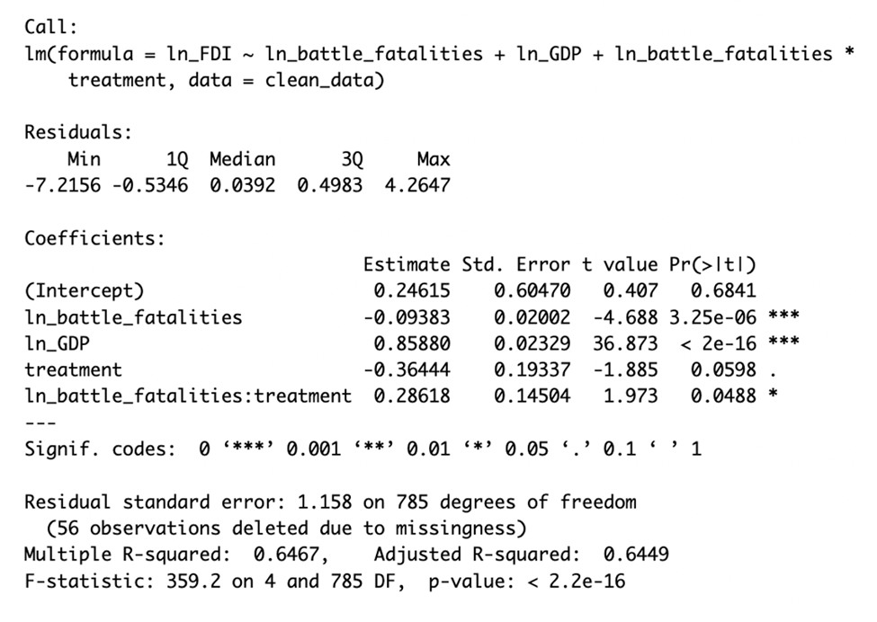

**References:**

Button, Kenneth, Soogwan Doh, and Junyang Yuan. "The role of small airports in economic development." *Journal of airport management* 4.2 (2010): 125-136.

Chalabi, Margery al. "The economic impact of a major airport." *Ekistics* (2002): 243-249.

Cristea, Anca D. "The role of aviation networks for urban development." *Journal of Regional Science* 63.4 (2023): 947-980.

Frye, Dustin. "Transportation networks and the geographic concentration of employment." *Review of Economics and Statistics* (2024): 1-34.

Dusek, Tamás, Miklós Lukovics, and Patrick Bohl. "The economic impact of the Budapest Airport on the local economy." (2011).

Gillen, David, and Holger Hinsch. "Measuring the economic impact of liberalization of international aviation on Hamburg airport." *Journal of Air Transport Management* 7.1 (2001): 25-34.

Hakfoort, Jacco, Tom Poot, and Piet Rietveld. "The regional economic impact of an airport: The case of Amsterdam Schiphol Airport." *Regional Studies* 35.7 (2001): 595-604.

Karlsson, Joakim, J. Richard Ludders, Dale Wilde, Darren Mochrie, and Craig Seymour. *Airport economic impact methods and models*. No. Project 11-03, Topic 03-03. 2008.

Ke, Meihong, Douglas Baker, and Christy Collis. "Impact of airports on landside industrial development: a case study of Brisbane airport." *Land* 12.7 (2023): 1327.

Luke, Rose, and Jackie Walters. "The economic impact of South Africa's international airports." *Journal of Transport and Supply Chain Management* 4.1 (2010): 120-137.

McGraw, Marquise J. "The role of airports in city employment growth, 1950–2010." *Journal of Urban Economics* 116 (2020): 103240.

McGraw, Marquise J. "The Heterogeneous Impact of Airports on Population and Employment Growth in Cities☆." *The economics of airport operations*. Emerald Publishing Limited, 2017. 261-312.

Shilpi, Forhad, M. Shahe Emran, Brian Blankespoor, and Harold Coulombe. "Temporary trade shocks and regional development: evidence from the closure of Abidjan port." *Journal of Economic Geography* 24, no. 2 (2024): 333-352.

Smith, C. D. M. "The Economic Impact of Commercial Airports in 2010." *Airports Council International–North America. Retrieved February* 28 (2012): 2013.

1. Becker and Schultze: Department of Economics, Duke University

   Devine: National Economic Council and Boston College

   We gratefully acknowledge valuable research assistance from Eva Spektorov.